Native Village of Kluti-Kaah
Tl'aticae'e
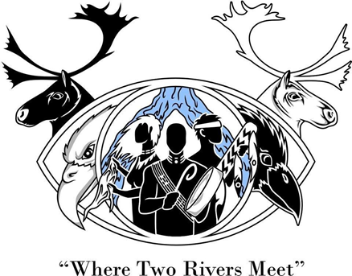

GYM FACILITY-USE
INDIVIDUAL liability Waiver FORM

- The use of tobacco, vaping, possession of firearms, possession, or use of alcohol and/or illegal drugs, fighting, betting or other forms of illegal gambling is strictly prohibited upon the NVKK Premises or within any facility.
- Individuals utilizing the locker rooms are responsible for providing their own padlock/combination lock. The NVKK reserves the right to cut any lock as needed.
- NVKK is not responsible for property that is lost, stolen, or damaged while in, on, or about the premises.
- The NVKK does not and shall not discriminate based on race, color, religion (creed), military status, gender, gender expression, age, sexual orientation, national origin, disability, marital status, change in marital status, pregnancy, or parenthood.
- All children under the age of 18 years-old MUST BE ACCOMPANY and SUPERVISED BY A PARENT/GUARDIAN AT ALL TIMES WITHIN THE NVKK FACILITIES.

Gym & Bleacher Guidelines
- Proper athletic shoes (non-marking tennis shoes) must be worn at all times on the gym floor. Examples of prohibited shoes include, but are not limited to, high heels, cleats, sandals, stocking feet and/or hard-sole shoes.
- Disassembling or moving equipment that has been set up is prohibited.
- Food and beverages are prohibited in the gym, except for non-glass bottles containing only water. Liquids damage wood floors, sodas and juice will not be permitted. If water is spilled, the area must be cleaned up immediately. The use of household cleaning products on the gym floor is strictly prohibited.
- All food is prohibited in the gym. In the event of concessions sold, the Common Area will be designated for eating.
- Grabbing or hanging on the net or rim is strictly prohibited due to the risk of injury and potential damage to the equipment.
- Bicycles, skateboards, roller skates, rollerblades, electric and non-electric scooters are prohibited.
- Baseball, football and other activities or equipment deemed unsafe in the gymnasium are prohibited.
- Good sportsmanship and proper conduct are expected by all users.
- Disorderly conduct, abuse of the facility and equipment is not permitted.
- Screaming, yelling, or use of offensive language will not be permitted.
I further agree that, in the event that the NVKK deems it necessary to administer emergency first aid, CPR or AED or to remove me from its facility or premises or to seek emergency medical care for me that, by signing this document, I am giving the NVKK permission to: administer emergency first aid or CPR or AED, secure emergency transport or medical care and/or disclose any medical information it may have about me to any health care provider which may become involved in my care, treatment or removal from the NVKK. By signing this document, I am waiving any right to object to or bring any type of action or claim against the NVKK for its administration of emergency first aid or CPR or AED, or for securing emergency transport or medical care and/or for the disclosure of personal medical information it may have about me to any health-related person who becomes involved in my care or removal from the NVKK.

I hereby voluntarily release, forever discharge, and agree to indemnify and hold harmless the NVKK from any and all claims, demands, or causes of action, which are in any way connected with my participation in this activity or my use of the NVKK equipment or facilities, including any such Claims which allege any theory of negligence including negligent acts or omissions of the NVKK. What I am agreeing to in this clause is that, beyond the legal application of the inherent risk and assumption of the risk provisions, this separate provision means I am waiving all claims I might have against the NVKK sounding in negligence. I agree that the specific risks of death, injury or other property damage are clear and unambiguous to me and that, even if a specific mechanism of injury is not listed in this NVKK Release and Waiver Contract document it is my express agreement not to the NVKK liable for negligence related to my death or injury or any other style of damage.

By signing this document, I acknowledge that if anyone is hurt or killed or property is damaged during my participation in or use of the NVKK activities or premises or facilities or rental equipment, I may be found by a court of law to have waived my right to maintain a lawsuit against the NVKK.

Tsin’aen (Thank you) for helping us take care of our facility.

I HAVE HAD SUFFICIENT OPPORTUNITY TO READ THIS ENTIRE DOCUMENT. I HAVE READ AND UNDERSTOOD IT, AND I AGREE TO BE BOUND BY ITS TERMS.

__________________________________ |  |  |  |  | __________________________________
Participant Signature |  |  |  |  | Printed Name
Birthdate: ____________________________ |  |  |  |  | MALE / FEMALE
Email: __________________________________________________________________
In case of Emergency, PLEASE CONTACT
_________________________________________ |  |  |  |  |  |  | (_______)_____________________
NAME / RELATIONSHIP |  |  |  |  |  |  | PHONE NUMBER

(Office-use only)

Date Received: ________________ Received By: ___________________________

